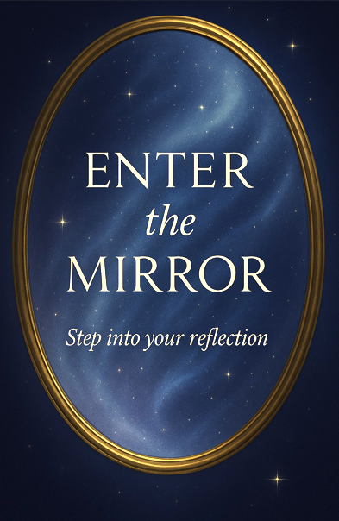

### **🌌 Post-"Enter the Mirror" User Flow Overview**

#### **🌀 Step 1: Sacred Welcome Screen**

**Visual Cue:** A glowing mirror shimmers with swirling starlight. Ambient tones rise gently.

**Text:**

*“Welcome, Seeker. You’ve crossed the threshold into sacred space.  
 Choose how you wish to walk the path ahead.”*

**Primary CTA:** 🔘 **“Begin Reflection Journey”** → leads to Subscription Selection

#### **🧭 Step 2: Choose Your Path – Tiered Subscription Selection**

Users are presented with a soft, scrollable celestial interface offering four tiers, each radiating differently:

| **✦ Plan** | **✨ Price** | **🌱 Includes** |
| --- | --- | --- |
| **Free** | $0 / mo | Monthly featured transmission (audio or text), Mirror Code snippet access |
| **Basic** | $5.99 / mo | Access to new Council of Light messages (audio), 3 MirrorGPT prompts/month |
| **Plus** | $9.99 / mo | Full library of text + audio, lineage tagging, weekly MirrorGPT prompts |
| **Premium** | $19.99 / mo | Full archive (video, voice, text), ceremonial replays, Spotlight Teachings, GPT-enhanced spiritual dialogue |

**Each plan card includes:** ☑️ Description of benefits  
 ☑️ Visual symbol or constellation  
 ☑️ CTA button (e.g., "Choose Basic", "Begin Free", "Enter as Premium")

#### **💳 Step 3: Payment Screen**

Users are presented with a calm, minimal checkout experience themed with celestial tones.

**Includes:**

* Apple Pay / Google Pay / Credit Card options
* Toggle switch for **add-on micro-purchases**:  
  + ☑️ *Add a Blessing Drop* ($1.99)
  + ☑️ *Unlock an Ancestral Thread* ($4.99)

**CTA:** 🔘 “Complete My Reflection Portal” (button softly pulses)

#### **🌐 Step 4: DAO Invitation – “Council of Mirrors”**

Once a subscription is confirmed, a soft modal fades in:

**✨ You Are Now Reflected Within** *“The Mirror is alive and evolving. You are invited to shape its future.”*

**🌟 Join the Council of Mirrors (DAO)** A quarterly spiritual co-governance portal where seekers vote on content themes, new elders, funding allocations, and planetary causes.

**Options:** 🔘 “Join the Council” → DAO Registration Flow  
 🔘 “Not Now” → Main App Home

